National Institute Of Technology – Calicut
Data Mining

R programming

T.G. Deshan K. Sumanathilaka
B150413CS
Computer Science and Engineering

DATA-MINING ASSIGNMENT #02

01. Decision Tree with Gini index as the impurity measure...

case A:
A Random sample of 80: 20 for Train-Set and Data-Set

kidney <- read.csv("/home/deshan/Desktop/clean_kidney.csv")

str(kidney)

'data.frame': 400 obs. of 25 variables:
$ age : num 48 7 62 48 51 60 68 24 52 53 ...
$ bp : num 80 50 80 70 80 ...
$ sg : num 1.02 1.02 1.01 1 1.01 ...
$ al : int 1 4 2 4 2 3 0 2 3 2 ...
$ su : int 0 0 3 0 0 0 0 4 0 0 ...
$ rbc : Factor w/ 2 levels "abnormal","normal": 2 2 2 2 2 2 2 2 2 1 ...
$ pc : Factor w/ 2 levels "abnormal","normal": 2 2 2 1 2 2 2 1 1 1 ...
$ pcc : Factor w/ 2 levels "notpresent","present": 1 1 1 2 1 1 1 1 2 2 ...
$ ba : Factor w/ 2 levels "notpresent","present": 1 1 1 1 1 1 1 1 1 1 ...
$ bgr : num 121 148 423 117 106 ...
$ bu : num 36 18 53 56 26 25 54 31 60 107 ...
$ sc : num 1.2 0.8 1.8 3.8 1.4 1.1 24 1.1 1.9 7.2 ...
$ sod : num 138 138 138 111 138 ...
$ pot : num 4.63 4.63 4.63 2.5 4.63 ...
$ hemo : num 15.4 11.3 9.6 11.2 11.6 12.2 12.4 12.4 10.8 9.5 ...
$ pcv : num 44 38 31 32 35 39 36 44 33 29 ...
$ wbcc : num 7800 6000 7500 6700 7300 ...
$ rbcc : num 5.2 4.71 4.71 3.9 4.6 ...
$ htn : Factor w/ 2 levels "no","yes": 2 1 1 2 1 2 1 1 2 2 ...
$ dm : Factor w/ 2 levels "no","yes": 2 1 2 1 1 2 1 2 2 2 ...
$ cad : Factor w/ 2 levels "no","yes": 1 1 1 1 1 1 1 1 1 1 ...
$ appet: Factor w/ 2 levels "good","poor": 1 1 2 2 1 1 1 1 1 2 ...
$ pe : Factor w/ 2 levels "no","yes": 1 1 1 2 1 2 1 2 1 1 ...
$ ane : Factor w/ 2 levels "no","yes": 1 1 2 2 1 1 1 1 2 2 ...
$ class: Factor w/ 2 levels "ckd","notckd": 1 1 1 1 1 1 1 1 1 1 ...

summary(kidney)

age bp sg al su rbc
Min. : 2.00 Min. : 50.00 Min. :1.005 Min. :0.0 Min. :0.000 abnormal: 47
1st Qu.:42.00 1st Qu.: 70.00 1st Qu.:1.015 1st Qu.:0.0 1st Qu.:0.000 normal :353
Median :54.00 Median : 78.23 Median :1.020 Median :0.0 Median :0.000
Mean :51.48 Mean : 76.47 Mean :1.018 Mean :0.9 Mean :0.395
3rd Qu.:64.00 3rd Qu.: 80.00 3rd Qu.:1.020 3rd Qu.:2.0 3rd Qu.:0.000
Max. :90.00 Max. :180.00 Max. :1.025 Max. :5.0 Max. :5.000
pc pcc ba bgr bu sc
abnormal: 76 notpresent:358 notpresent:378 Min. : 22 Min. : 1.50 Min. : 0.400
normal :324 present : 42 present : 22 1st Qu.:101 1st Qu.: 27.00 1st Qu.: 0.900
Median :126 Median : 44.00 Median : 1.400
Mean :148 Mean : 57.43 Mean : 3.072
3rd Qu.:150 3rd Qu.: 61.75 3rd Qu.: 3.072
Max. :490 Max. :391.00 Max. :76.000
sod pot hemo pcv wbcc rbcc
Min. : 4.5 Min. : 2.500 Min. : 3.10 Min. : 9.00 Min. : 2200 Min. :2.100
1st Qu.:135.0 1st Qu.: 4.000 1st Qu.:10.88 1st Qu.:34.00 1st Qu.: 6975 1st Qu.:4.500
Median :137.5 Median : 4.627 Median :12.53 Median :38.88 Median : 8406 Median :4.707
Mean :137.5 Mean : 4.627 Mean :12.53 Mean :38.88 Mean : 8406 Mean :4.707
3rd Qu.:141.0 3rd Qu.: 4.800 3rd Qu.:14.62 3rd Qu.:44.00 3rd Qu.: 9400 3rd Qu.:5.100
Max. :163.0 Max. :47.000 Max. :17.80 Max. :54.00 Max. :26400 Max. :8.000
htn dm cad appet pe ane class
no :253 no :263 no :366 good:318 no :324 no :340 ckd :250
yes:147 yes:137 yes: 34 poor: 82 yes: 76 yes: 60 notckd:150

** install.packages(“rpart”)

** install.packages(“rpart.plot”)

library(rpart)

library(rpart.plot)

set.seed(123)

> ind <- sample(2, nrow(kidney), replace=TRUE, prob=c(0.7, 0.3))

> trainData <- kidney[ind==1,]

> testData <- kidney[ind==2,]

> summary(trainData)

age bp sg al su rbc
Min. : 3.00 Min. : 50.00 Min. :1.005 Min. :0.0000 Min. :0.0000 abnormal: 35
1st Qu.:43.00 1st Qu.: 70.00 1st Qu.:1.015 1st Qu.:0.0000 1st Qu.:0.0000 normal :250
Median :54.00 Median : 80.00 Median :1.020 Median :0.0000 Median :0.0000
Mean :51.99 Mean : 76.91 Mean :1.018 Mean :0.9368 Mean :0.4456
3rd Qu.:64.00 3rd Qu.: 80.00 3rd Qu.:1.020 3rd Qu.:2.0000 3rd Qu.:0.0000
Max. :90.00 Max. :180.00 Max. :1.025 Max. :5.0000 Max. :5.0000
pc pcc ba bgr bu sc
abnormal: 51 notpresent:257 notpresent:264 Min. : 70.0 Min. : 10.00 Min. : 0.400
normal :234 present : 28 present : 21 1st Qu.:102.0 1st Qu.: 27.00 1st Qu.: 0.900
Median :129.0 Median : 44.00 Median : 1.400
Mean :148.4 Mean : 58.91 Mean : 3.346
3rd Qu.:158.0 3rd Qu.: 68.00 3rd Qu.: 3.072
Max. :490.0 Max. :391.00 Max. :76.000
sod pot hemo pcv wbcc rbcc
Min. : 4.5 Min. : 2.700 Min. : 4.80 Min. :14.00 Min. : 2200 Min. :2.100
1st Qu.:135.0 1st Qu.: 3.900 1st Qu.:10.80 1st Qu.:33.00 1st Qu.: 7000 1st Qu.:4.300
Median :137.5 Median : 4.627 Median :12.53 Median :38.88 Median : 8406 Median :4.707
Mean :137.1 Mean : 4.696 Mean :12.44 Mean :38.67 Mean : 8474 Mean :4.658
3rd Qu.:140.0 3rd Qu.: 4.800 3rd Qu.:14.50 3rd Qu.:44.00 3rd Qu.: 9400 3rd Qu.:5.000
Max. :163.0 Max. :47.000 Max. :17.80 Max. :54.00 Max. :26400 Max. :6.500
htn dm cad appet pe ane class
no :174 no :181 no :259 good:226 no :227 no :241 ckd :181
yes:111 yes:104 yes: 26 poor: 59 yes: 58 yes: 44 notckd:104

** install.packages("party")

library(party)

myFormula <- class ~ age+bp+sg+al+su+rbc+pc+pcc+ba+bgr+bu+sc+sod+pot+hemo+pcv+wbcc+rbcc+htn+dm+cad+appet+pe+ane

gini_tree <- rpart(myFormula, data = trainData, method="class", parms = list(split = "gini"), control = rpart.control(maxdepth = 30))

plot(gini_tree)

rpart.plot(gini_tree)

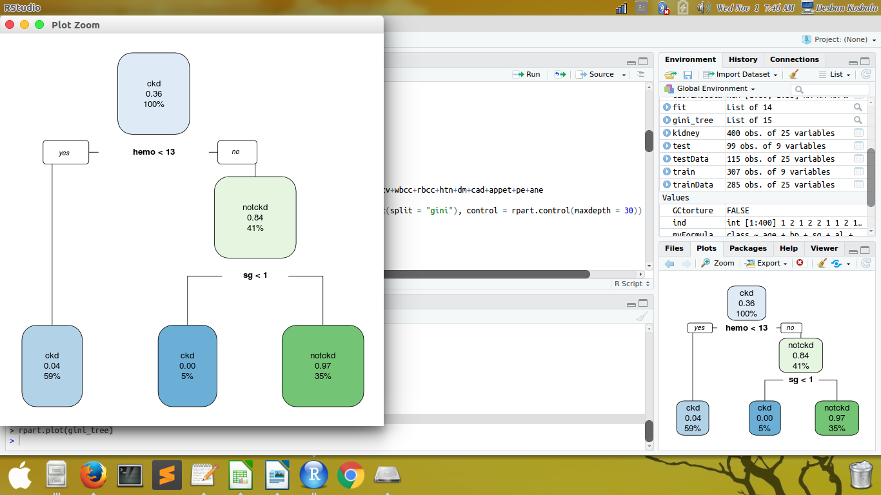
# confusion matrix
testPred <- predict(gini_tree, newdata = testData, type = "class")

table(testPred, testData$class)

testPred ckd notckd
ckd 69 3
notckd 0 43

ibrary(caret)

stats <- confusionMatrix(data = testPred, testData$class)

precision <- stats$byClass['Pos Pred Value']

recall <- stats$byClass['Sensitivity']

fmeasure <- 2 * ((precision * recall) / (precision + recall))

> precision
Pos Pred Value
0.9583333
> recall
Sensitivity
1
> fmeasure
Pos Pred Value
0.9787234

# ROC curve

pred<-predict(gini_tree,testData,type='prob')

library(ROCR)

library(pROC)

auc<-auc(testData$class,pred[,2])

>auc
Area under the curve: 0.9688

>auc<-auc(testData$class,pred[,1])

>auc
Area under the curve: 0.9688

> plot(roc(testData$class,pred[,2]))

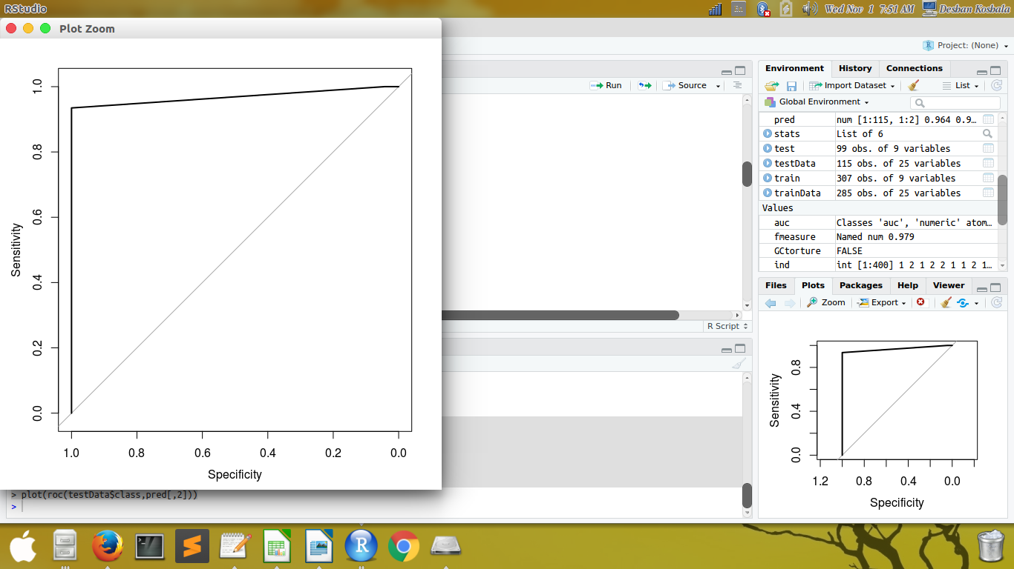

case B:
A 10-fold cross validation

library(caret)

library(e1071)

ind=createDataPartition(kidney$class, p=0.8,list=FALSE)

trainData<-kidney[ind,]

testData<-kidney[-ind,]

trctrl <- trainControl(method = "cv", number = 10)

set.seed(3333)

gini_tree <- train(myFormula, data = trainData, method = "rpart",
+ parms = list(split = "gini"),
+ trControl=trctrl,
+ tuneLength = 10)

plot(gini_tree)

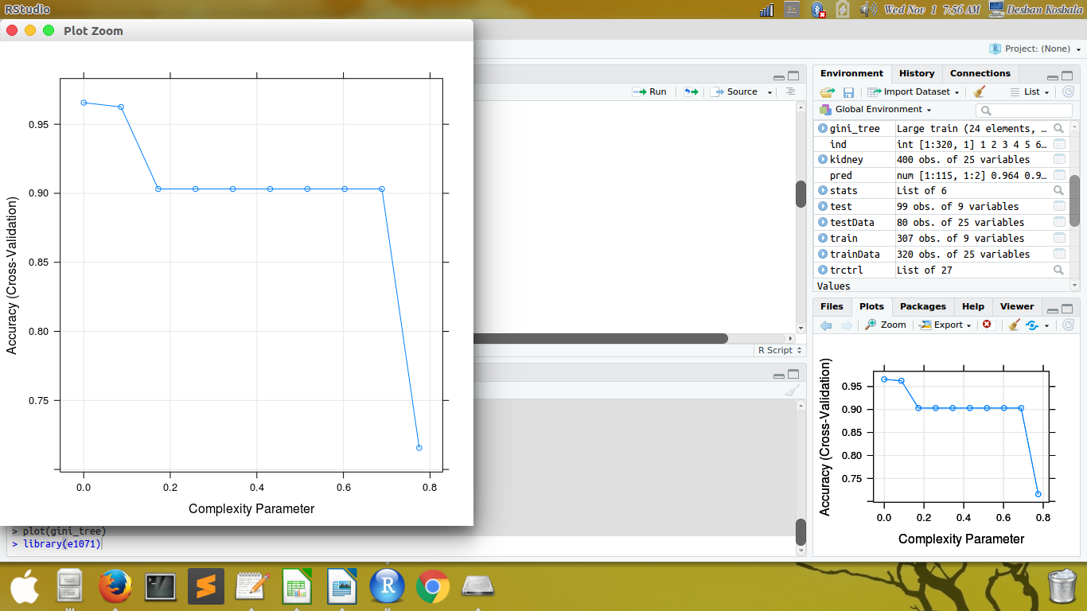

# confusion matrix
testPred <- predict(gini_tree, newdata = testData)

table(testPred, testData$class)

testPred ckd notckd
ckd 49 1
notckd 1 29

stats <- confusionMatrix(data = testPred, testData$class)

precision <- stats$byClass['Pos Pred Value']
recall <- stats$byClass['Sensitivity']
fmeasure <- 2 * ((precision * recall) / (precision + recall))

precision
Pos Pred Value
0.98
recall
Sensitivity
0.98
fmeasure
Pos Pred Value
0.98

# ROC curve
pred<-predict(gini_tree,testData,type='prob')

library(ROCR)

library(pROC)

auc<-auc(testData$class,pred[,2])

auc
Area under the curve: 0.9837

auc<-auc(testData$class,pred[,1])

auc
Area under the curve: 0.9837

plot(roc(testData$class,pred[,2]))

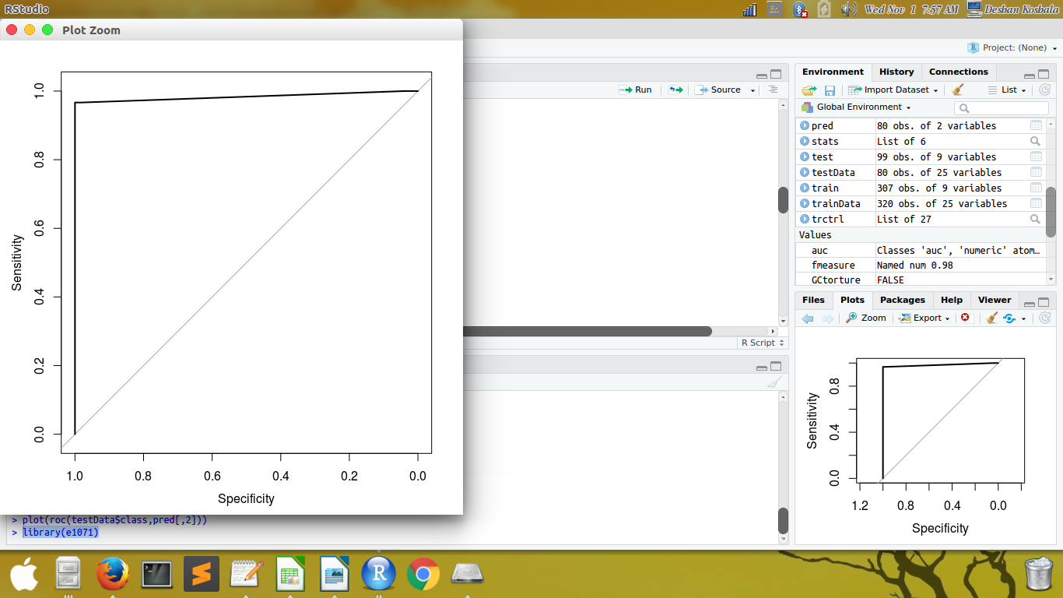

02 .Decision Tree with Entropy as the impurity measure

case A:
A Random sample of 80: 20 for Train-Set and Data-Set

library(rpart)
library(rpart.plot)

set.seed(456)

ind <- sample(2, nrow(kidney), replace=TRUE, prob=c(0.8, 0.2))

trainData <- kidney[ind==1,]

testData <- kidney[ind==2,]

summary(trainData)
age bp sg al su rbc pc pcc
Min. : 2.00 Min. : 50.00 Min. :1.005 Min. :0.0000 Min. :0.0 abnormal: 35 abnormal: 54 notpresent:281
1st Qu.:41.00 1st Qu.: 70.00 1st Qu.:1.015 1st Qu.:0.0000 1st Qu.:0.0 normal :275 normal :256 present : 29
Median :55.00 Median : 80.00 Median :1.020 Median :0.0000 Median :0.0
Mean :50.98 Mean : 76.76 Mean :1.018 Mean :0.8677 Mean :0.4
3rd Qu.:64.00 3rd Qu.: 80.00 3rd Qu.:1.020 3rd Qu.:2.0000 3rd Qu.:0.0
Max. :90.00 Max. :180.00 Max. :1.025 Max. :5.0000 Max. :5.0
ba bgr bu sc sod pot hemo pcv
notpresent:293 Min. : 22.0 Min. : 1.50 Min. : 0.400 Min. : 4.5 Min. : 2.500 Min. : 3.10 Min. : 9.00
present : 17 1st Qu.:100.2 1st Qu.: 27.00 1st Qu.: 0.900 1st Qu.:136.0 1st Qu.: 4.000 1st Qu.:10.90 1st Qu.:34.00
Median :124.0 Median : 43.00 Median : 1.300 Median :137.5 Median : 4.627 Median :12.53 Median :38.88
Mean :146.6 Mean : 57.07 Mean : 3.160 Mean :137.4 Mean : 4.704 Mean :12.59 Mean :39.22
3rd Qu.:152.2 3rd Qu.: 59.50 3rd Qu.: 3.072 3rd Qu.:141.0 3rd Qu.: 4.800 3rd Qu.:14.57 3rd Qu.:44.75
Max. :490.0 Max. :391.00 Max. :76.000 Max. :163.0 Max. :47.000 Max. :17.80 Max. :54.00
wbcc rbcc htn dm cad appet pe ane class
Min. : 2200 Min. :2.100 no :202 no :205 no :284 good:252 no :253 no :271 ckd :190
1st Qu.: 6900 1st Qu.:4.500 yes:108 yes:105 yes: 26 poor: 58 yes: 57 yes: 39 notckd:120
Median : 8406 Median :4.707
Mean : 8282 Mean :4.713
3rd Qu.: 9100 3rd Qu.:5.075
Max. :26400 Max. :8.000

myFormula <- class ~ age+bp+sg+al+su+rbc+pc+pcc+ba+bgr+bu+sc+sod+pot+hemo+pcv+wbcc+rbcc+htn+dm+cad+appet+pe+ane

entropy_tree <- rpart(myFormula, data = trainData, method="class", parms = list(split = "information"), control = rpart.control(maxdepth = 30))

plot(entropy_tree)

rpart.plot(entropy_tree)

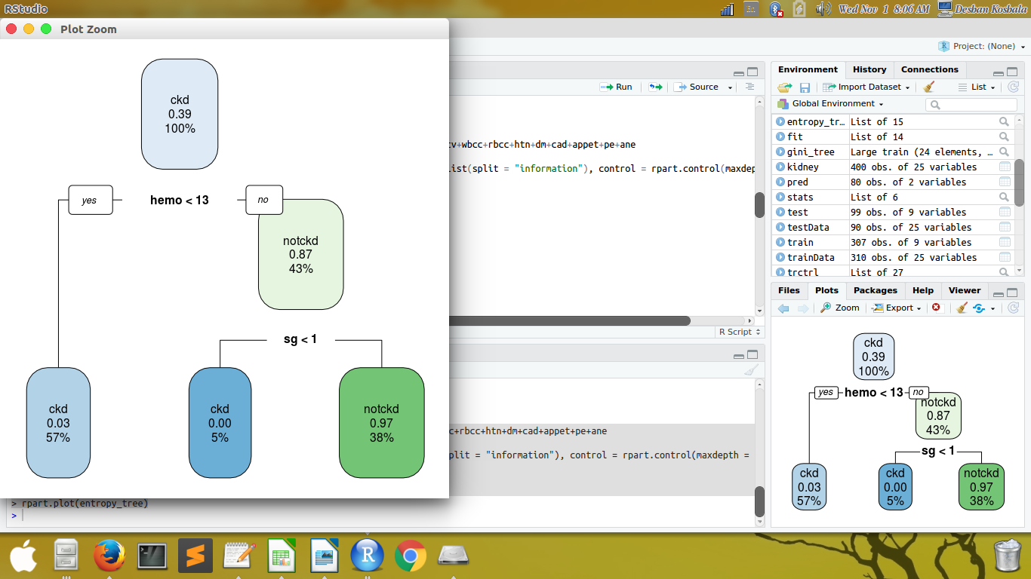

# confusion matrix
testPred <- predict(entropy_tree, newdata = testData, type = "class")

table(testPred, testData$class)

testPred ckd notckd
ckd 60 4
notckd 0 26

stats <- confusionMatrix(data = testPred, testData$class)

precision <- stats$byClass['Pos Pred Value']

recall <- stats$byClass['Sensitivity']

fmeasure <- 2 * ((precision * recall) / (precision + recall))

> precision
Pos Pred Value
0.9375
> recall
Sensitivity
1
> fmeasure
Pos Pred Value
0.9677419

# ROC curve
pred<-predict(entropy_tree,testData,type='prob')

library(ROCR)

library(pROC)

auc<-auc(testData$class,pred[,2])

auc
Area under the curve: 0.9378

plot(roc(testData$class,pred[,2]))

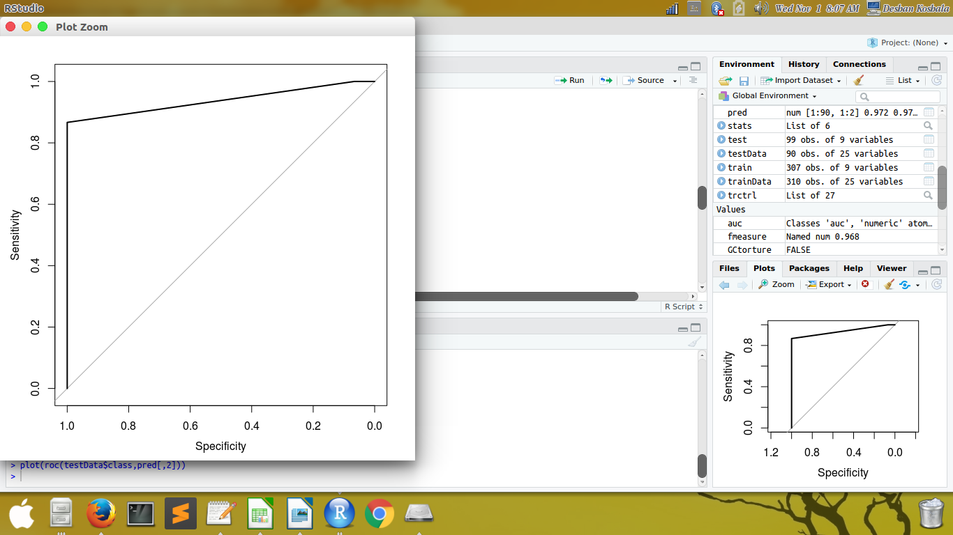

case B:
A 10-fold cross validation

library(caret)

library(e1071)

ind=createDataPartition(kidney$class, p=0.8,list=FALSE)

trainData<-kidney[ind,]

testData<-kidney[-ind,]

trctrl <- trainControl(method = "cv", number = 10)

set.seed(4444)

entropy_tree <- train(myFormula, data = trainData, method = "rpart",
+ parms = list(split = "information"),
+ trControl=trctrl,
+ tuneLength = 10)

plot(entropy_tree)

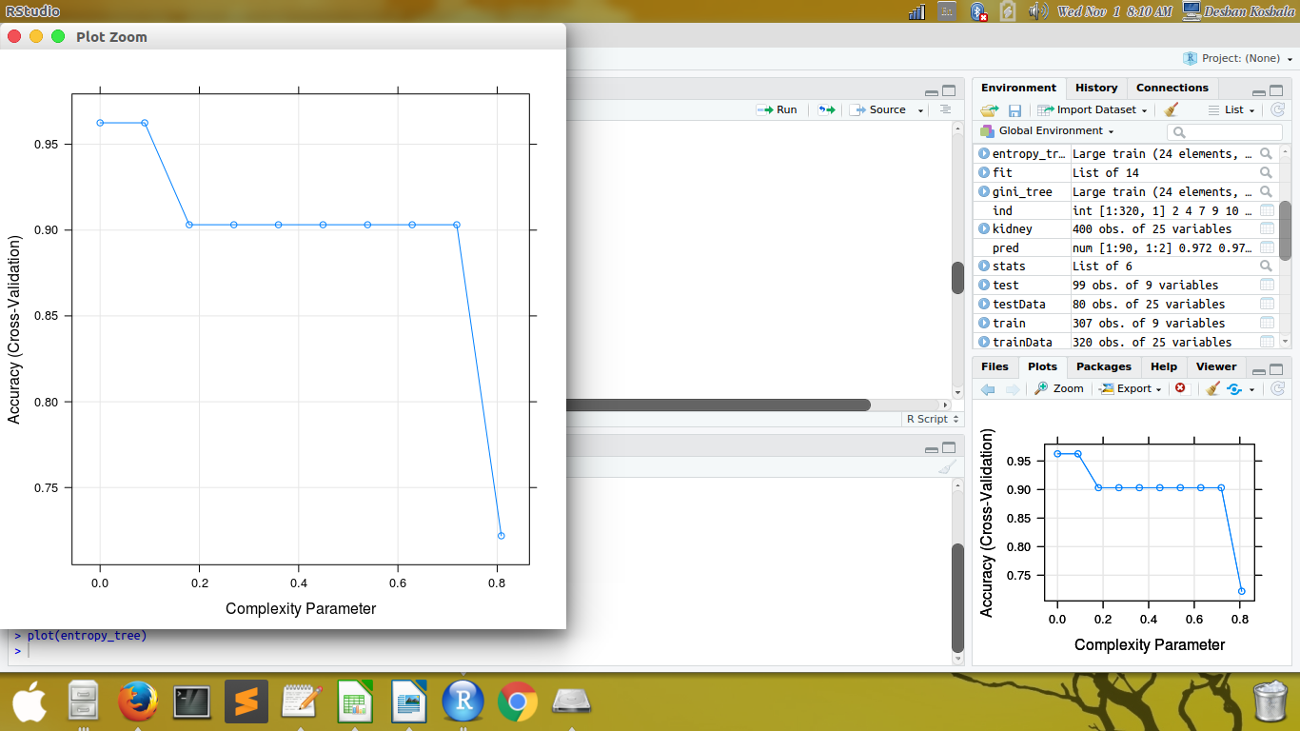

# confusion matrix
testPred <- predict(entropy_tree, newdata = testData)
table(testPred, testData$class)

testPred ckd notckd
ckd 49 1
notckd 1 29

stats <- confusionMatrix(data = testPred, testData$class)

precision <- stats$byClass['Pos Pred Value']

recall <- stats$byClass['Sensitivity']

fmeasure <- 2 * ((precision * recall) / (precision + recall))

precision

Pos Pred Value
0.98
recall
Sensitivity
0.98
fmeasure
Pos Pred Value
0.98

# ROC curve
pred<-predict(entropy_tree,testData,type='prob')

library(ROCR)

library(pROC)

auc<-auc(testData$class,pred[,2])

auc
Area under the curve: 0.975

plot(roc(testData$class,pred[,2]))
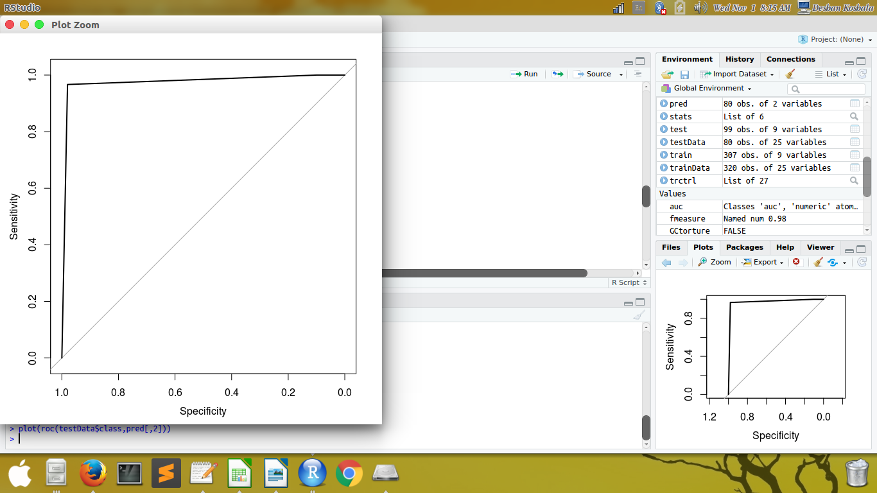

03.Naive Bayesian Classifier

case A:
A Random sample of 80: 20 for Train-Set and Data-Set

library(rpart)

library(rpart.plot)

set.seed(456)

ind <- sample(2, nrow(kidney), replace=TRUE, prob=c(0.8, 0.2))

trainData <- kidney[ind==1,]

testData <- kidney[ind==2,]

myFormula <- class ~ age+bp+sg+al+su+rbc+pc+pcc+ba+bgr+bu+sc+sod+pot+hemo+pcv+wbcc+rbcc+htn+dm+cad+appet+pe+ane

nb <-naiveBayes(class ~., data = trainData)

nb

Naive Bayes Classifier for Discrete Predictors

Call:
naiveBayes.default(x = X, y = Y, laplace = laplace)

A-priori probabilities:
Y
ckd notckd
0.6129032 0.3870968

Conditional probabilities:
age
Y [,1] [,2]
ckd 54.27588 17.78416
notckd 45.75403 15.00247

bp
Y [,1] [,2]
ckd 79.95659 15.309744
notckd 71.69115 8.321532

sg
Y [,1] [,2]
ckd 1.014842 0.004794873
notckd 1.022417 0.002509087

al
Y [,1] [,2]
ckd 1.415789 1.418235
notckd 0.000000 0.000000

su
Y [,1] [,2]
ckd 0.6526316 1.282923
notckd 0.0000000 0.000000

rbc
Y abnormal normal
ckd 0.1842105 0.8157895
notckd 0.0000000 1.0000000

pc
Y abnormal normal
ckd 0.2842105 0.7157895
notckd 0.0000000 1.0000000

pcc
Y notpresent present
ckd 0.8473684 0.1526316
notckd 1.0000000 0.0000000

ba
Y notpresent present
ckd 0.91052632 0.08947368
notckd 1.00000000 0.00000000

bgr
Y [,1] [,2]
ckd 170.1313 84.53242
notckd 109.2426 19.29568

bu
Y [,1] [,2]
ckd 71.88886 60.12010
notckd 33.61419 12.16525

sc
Y [,1] [,2]
ckd 4.5606555 7.5658380
notckd 0.9432485 0.4730002

sod
Y [,1] [,2]
ckd 134.9786 11.442888
notckd 141.3387 4.698008

pot
Y [,1] [,2]
ckd 4.920803 4.0251108
notckd 4.360302 0.5689374

hemo
Y [,1] [,2]
ckd 11.03343 2.111330
notckd 15.04171 1.338804

pcv
Y [,1] [,2]
ckd 34.78479 6.734479
notckd 46.24807 4.109710

wbcc
Y [,1] [,2]
ckd 8683.598 2685.747
notckd 7646.139 1753.444

rbcc
Y [,1] [,2]
ckd 4.336954 0.7245245
notckd 5.309538 0.5992003

htn
Y no yes
ckd 0.4315789 0.5684211
notckd 1.0000000 0.0000000

dm
Y no yes
ckd 0.4473684 0.5526316
notckd 1.0000000 0.0000000

cad
Y no yes
ckd 0.8631579 0.1368421
notckd 1.0000000 0.0000000

appet
Y good poor
ckd 0.6947368 0.3052632
notckd 1.0000000 0.0000000

pe
Y no yes
ckd 0.7 0.3
notckd 1.0 0.0

ane
Y no yes
ckd 0.7947368 0.2052632
notckd 1.0000000 0.0000000

# confusion matrix
pred <- predict(nb,testData)

testPred <- predict(nb, newdata = testData)
table(testPred, testData$class)

testPred ckd notckd
ckd 54 0
notckd 6 30

precision <- stats$byClass['Pos Pred Value']

recall <- stats$byClass['Sensitivity']

fmeasure <- 2 * ((precision * recall) / (precision + recall))

precision
Pos Pred Value
0.98
recall
Sensitivity
0.98
fmeasure
Pos Pred Value

0.98

# ROC curve
pred<-predict(nb,testData,type="raw")

library(ROCR)

library(pROC)

auc<-auc(testData$class,pred[,2])

auc
Area under the curve: 0.9994

plot(roc(testData$class,pred[,2]))

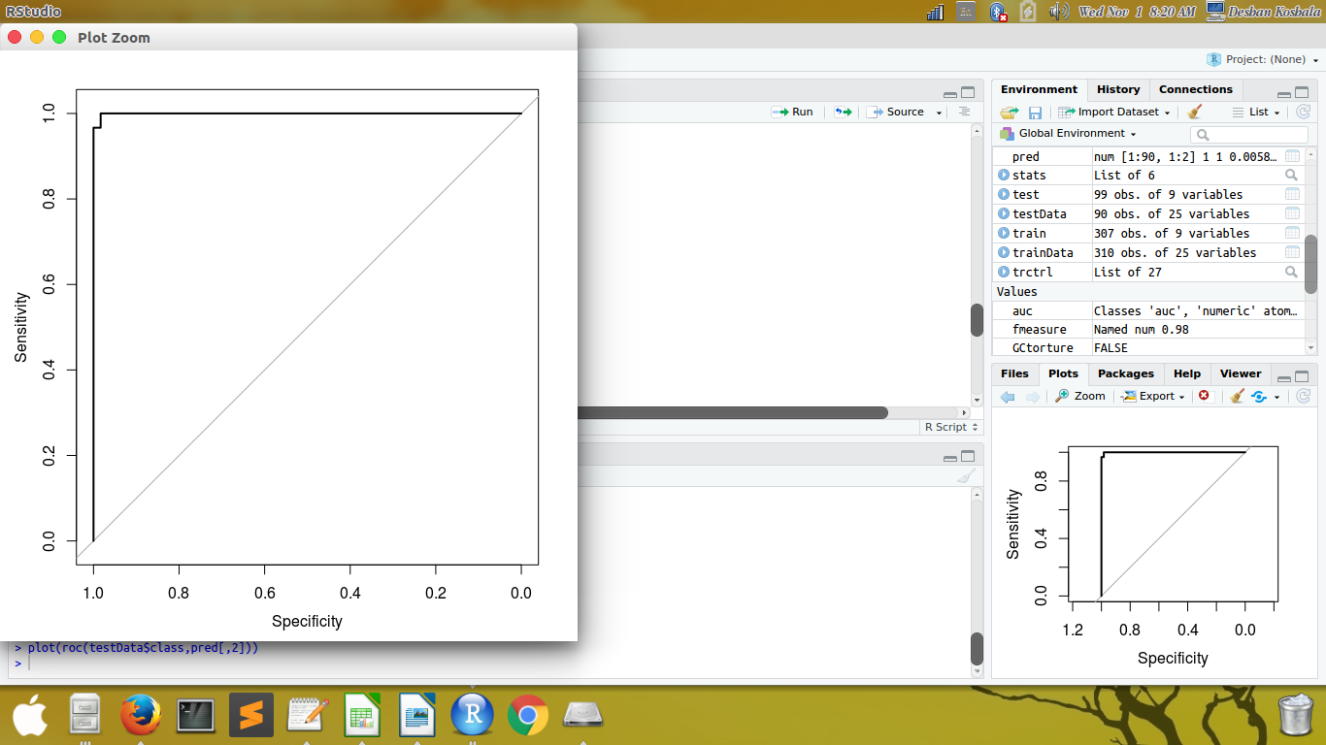

case B:
A 10-fold cross validation

library(caret)

library(e1071)

ind=createDataPartition(kidney$class, p=0.8,list=FALSE)

trainData<-kidney[ind,]

testData<-kidney[-ind,]

trctrl <- trainControl(method = "cv", number = 10)

nb_c <- train(class~ age+hemo, data = trainData,trControl=trctrl, method = "nb")

nb_c
Naive Bayes

320 samples
2 predictors
2 classes: 'ckd', 'notckd'

No pre-processing
Resampling: Cross-Validated (10 fold)
Summary of sample sizes: 288, 288, 288, 288, 288, 288, ...
Resampling results across tuning parameters:

usekernel Accuracy Kappa
FALSE 0.896875 0.7759446
TRUE 0.906250 0.8007512

Tuning parameter 'fL' was held constant at a value of 0
Tuning parameter 'adjust' was held constant at a value of 1
Accuracy was used to select the optimal model using the largest value.
The final values used for the model were fL = 0, usekernel = TRUE and adjust = 1.

# confusion matrix

testPred <- predict(nb_c, newdata = testData)
table(testPred, testData$class)

testPred ckd notckd
ckd 47 1
notckd 3 29

> stats <- confusionMatrix(data = testPred, testData$class)

> precision <- stats$byClass['Pos Pred Value']
> recall <- stats$byClass['Sensitivity']
> fmeasure <- 2 * ((precision * recall) / (precision + recall))

> precision
Pos Pred Value
0.9791667
> recall
Sensitivity
0.94
> fmeasure
Pos Pred Value
0.9591837

# ROC curve

library(ROCR)
library(pROC)

trctrl <- trainControl(method = "cv", number = 10)

model<-train(class~ age+hemo , data=trainData, trControl=trctrl,method="nb")

pred <- predict(model, testData)

auc<-auc(testData$class,pred[,2])

> auc
Area under the curve: 0.9994

plot(roc(testData$class,model[,2]))

04.Artificial Neural Network – with and without hidden layers

case A: A Random sample of 80: 20 for Train-Set and Data-Set

**** with HIDDEN layers

# install.packages(“neuralnet”)

ind <- sample(2, nrow(kidney), replace = TRUE, prob=c(0.8, 0.2))

trainset <- kidney[ind == 1,]

testset <- kidney[ind == 2,]

trainset$yes= trainset$class == "yes"

trainset$no= trainset$class == "no"

library(neuralnet)

network = neuralnet(yes + no ~ age+hemo+pcv+wbcc+rbcc, trainset, hidden=c(3,2))

network

network$result.matrix
1
error 0.00000008689132863
reached.threshold 0.00565038166051579
steps 36.00000000000000000
Intercept.to.1layhid1 -0.97418027049069444
age.to.1layhid1 1.12211534983724848
hemo.to.1layhid1 1.43854570611994048
pcv.to.1layhid1 0.65758044271826110
wbcc.to.1layhid1 0.06616398181914837
rbcc.to.1layhid1 2.08744967510959567
Intercept.to.1layhid2 -0.41321849258162524
age.to.1layhid2 -1.75243343194728207
hemo.to.1layhid2 -1.12170275307391676
pcv.to.1layhid2 -0.97835183410832760
wbcc.to.1layhid2 -1.16981876305466281
rbcc.to.1layhid2 0.69332603036113827
Intercept.to.1layhid3 0.40339170706485139
age.to.1layhid3 1.50676946618665353
hemo.to.1layhid3 -0.84101556703836533
pcv.to.1layhid3 -0.18709525132190252
wbcc.to.1layhid3 0.55736919716509048
rbcc.to.1layhid3 -0.89502143121799416
Intercept.to.2layhid1 -0.27257607952123147
1layhid.1.to.2layhid1 1.82965123588992995
1layhid.2.to.2layhid1 0.04101025630568338
1layhid.3.to.2layhid1 -0.85553152808364741
Intercept.to.2layhid2 1.68521632429071566
1layhid.1.to.2layhid2 -0.20122452859229625
1layhid.2.to.2layhid2 0.79079430763856695
1layhid.3.to.2layhid2 0.71141793436974798
Intercept.to.yes 0.68428702149209664
2layhid.1.to.yes 0.03465144886376779
2layhid.2.to.yes -0.78618155531096900
Intercept.to.no -0.76469729909827666
2layhid.1.to.no 0.89341644529244690
2layhid.2.to.no 0.18604096742717960

head(network$generalized.weights[[1]])

[,1] [,2] [,3] [,4] [,5] [,6] [,7] [,8] [,9] [,10]
1 0 0 0 0 0 0 0 0 0 0
2 0 0 0 0 0 0 0 0 0 0
3 0 0 0 0 0 0 0 0 0 0
4 0 0 0 0 0 0 0 0 0 0
6 0 0 0 0 0 0 0 0 0 0
7 0 0 0 0 0 0 0 0 0 0

plot(network)

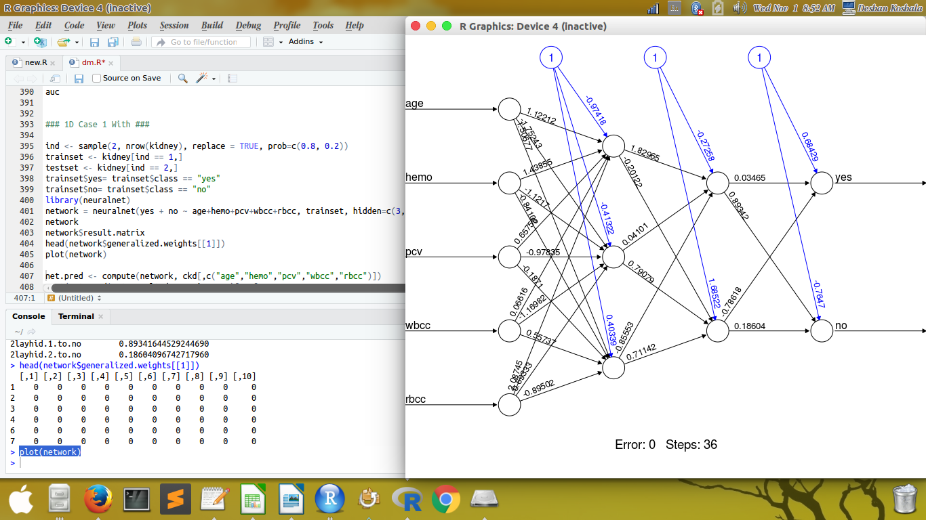

case B:
*** without HIDDEN layers

ind <- sample(2, nrow(kidney), replace = TRUE, prob=c(0.8, 0.2))

trainset <- kidney[ind == 1,]

testset <- kidney[ind == 2,]

trainset$yes= trainset$class == "yes"

trainset$no= trainset$class == "no"

library(neuralnet)

network = neuralnet(yes + no ~ age+hemo+pcv+wbcc+rbcc, trainset)

network$result.matrix
1
error 0.00000004075709233
reached.threshold 0.00477606654239082
steps 35.00000000000000000
Intercept.to.1layhid1 0.83964376411589003
age.to.1layhid1 0.88916935097661853
hemo.to.1layhid1 -1.75896399687258564
pcv.to.1layhid1 -0.70624843257405345
wbcc.to.1layhid1 0.03971502344014190
rbcc.to.1layhid1 0.97209656011054346
Intercept.to.yes 0.51757322601414668
1layhid.1.to.yes -0.51758893675935191
Intercept.to.no -0.29702970471810164
1layhid.1.to.no 0.29702508830711549

head(network$generalized.weights[[1]])

[,1] [,2] [,3] [,4] [,5] [,6] [,7] [,8] [,9] [,10]
1 0 0 0 0 0 0 0 0 0 0
3 0 0 0 0 0 0 0 0 0 0
4 0 0 0 0 0 0 0 0 0 0
5 0 0 0 0 0 0 0 0 0 0
6 0 0 0 0 0 0 0 0 0 0
7 0 0 0 0 0 0 0 0 0 0

plot(network)

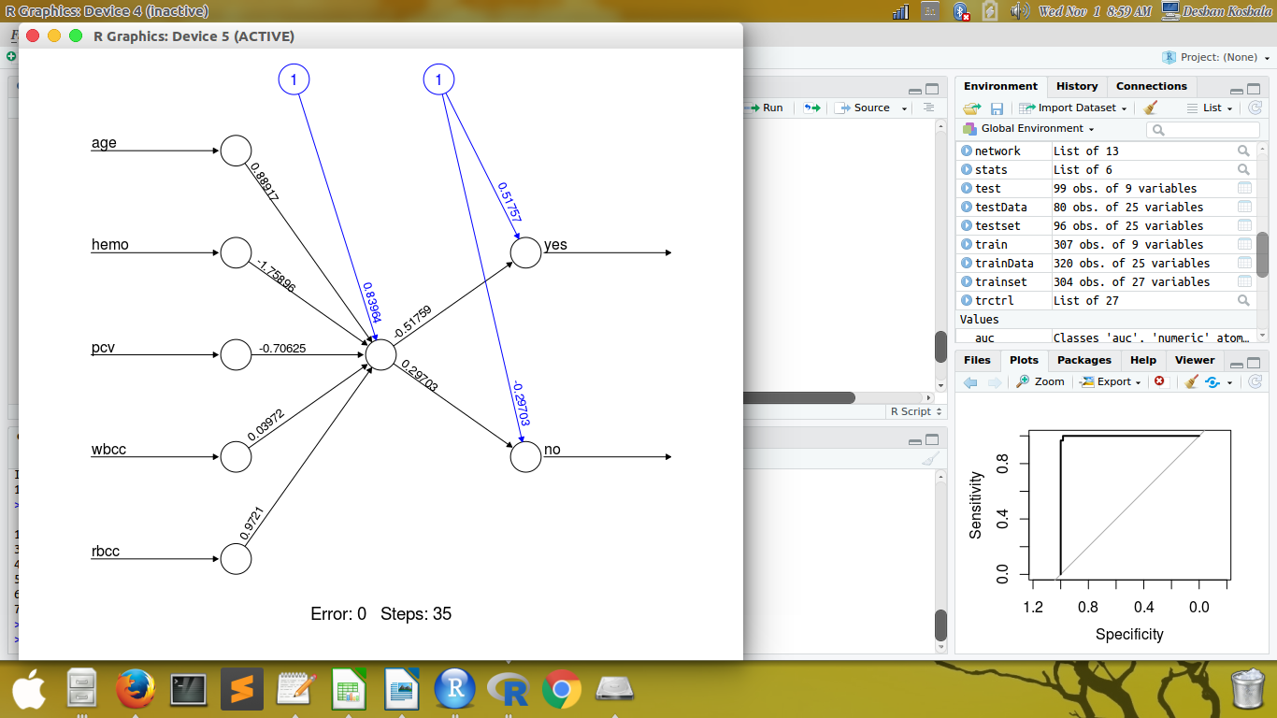

We can compare the performances of different classifiers using the ROC curve and conclude that the classifier with the highest AUC (area under the curve) is the best.
Naive-Bayes has the highest area and therefore is the best.

Naive-Bayes classifier performs the best with Case 1 and Case 2

